# Redemption

# 3D Game Applications

# http://upload.wikimedia.org/wikipedia/commons/2/2d/Epitech.png

# Submitted to the Department of Game and Mobile Contents

# at Keimyung University, Korea

# Head of Department: Dr. Joon Lee

# 

# Project Supervisor: Cathal McCosker

# 

# Team Members: Berger Thierry 7015123

# Bourgeon Matthieu 7015262

# Fremeaux Florian 7015200

# 

# Date Submitted: 5 May 2014

Index

Introduction 1

Informing the player 1

Simplicity 1

Entertaining the player 4

3 ways 4

Moving blocks 4

Maze 6

Avoid rocks 7

Ideal game experience 8

Introduction 8

First trial 10

Second trial 10

Third trial 11

Milestones 12

Story 13

Environment 13

Spirit diamond 13

Hero 15

The Gate of Trial 16

Music 17

ANNEXES: 18

# Figure Table

Figure 1 Early mock-up of the level 2

Figure 2 Last version of the level 3

Figure 3 First draft of moving blocks puzzle 4

Figure 4 Last version of moving blocks puzzle 5

Figure 5 Platform mini-game 6

Figure 6 Avoid rocks game 7

Figure 7 Title screen 8

Figure 8 Tutorial 9

Figure 9 First spirit gem design 13

Figure 10 Final spirit gem design 14

Figure 11 Character model 15

Figure 12 Gate of Trials 16

# Introduction

This is a game for our midterm exam of Unity class, 2015. The purpose is to use and show different features of our Character Controller developed during the first part of this semester.

It is a platform game at the 3rd person, in which you embody a demon trying to redeem itself. To do so, the player will have to retrieve 4 hearts to the golden door, which he will see at the beginning of the level.

Bring back 4 gems, by going through the different puzzles of the level, to a door to unlock it and go to the next level.

The player would be an evil person, seeking to repent its sins. To do that, he would need to bring 4 pure spirit gems to the exit door of its eternal world.

## Informing the player

A short introduction narrating the backstory of the game will be played at the beginning of the game.

# Simplicity

As the controls are pretty simple, arrows/WASD to move, jump with space, and mouse to look around, we will just show the instructions written if he needs it (via the menu), to avoid interferences with its gaming experience.

He can also get gems by stepping on it, and put them in the door by walking near it.

He can also push some rocks, different from the terrain so he can recognize them, by pushing them walking towards it.

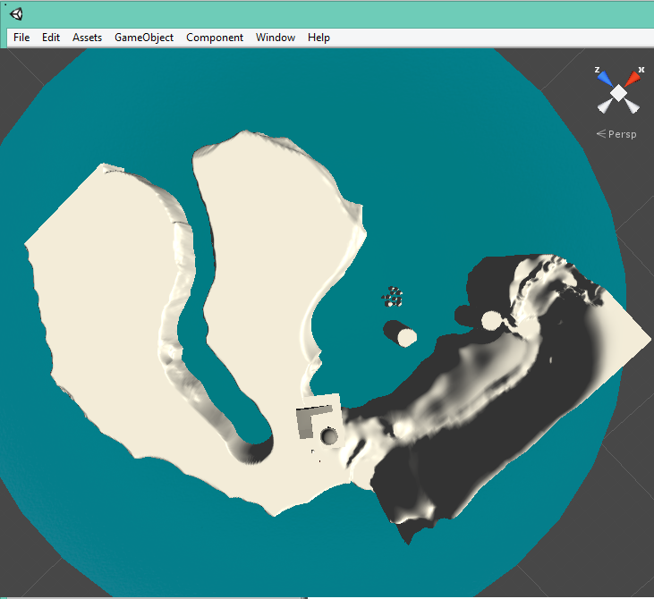

Figure 1 Early mock-up of the level

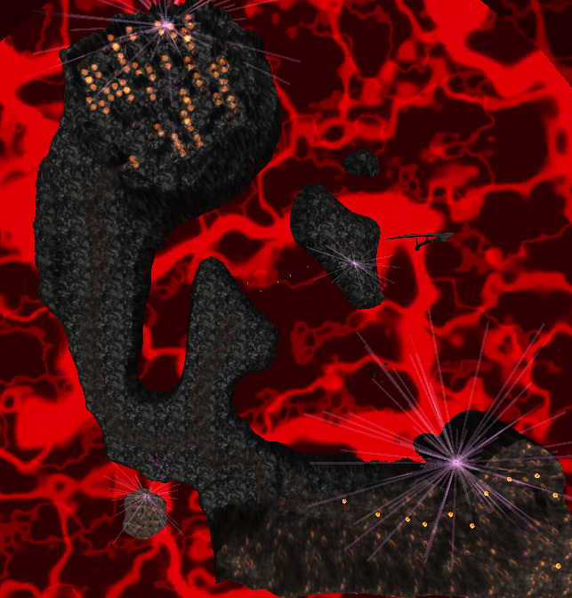

Figure 2 Last version of the level

# 

# Entertaining the player

## 3 ways

### Moving blocks

The player will have to move blocks in order to clear its path and progress towards the spirit gem. It will feature the ability of moving objects.

After a talk with our teacher, it was decided to add something to put pressure on the player during the puzzle. We decided to make the fire pillars (blocking the way of the player) fire projectiles to the player to prevent him to take his time to solve the puzzle.

Also, after our first playtesting session, we realized that the rules of the game where to unclear for most of the players that didn’t even realized that they could push objects. Instead, they just decided to jump their way through the puzzle (by jumping on the objects to push, then by jumping above the pillars. We also think that this idea was induced by a bug during the testing session that made the player jump higher than he should).

We then decided to block the entrance by one of those blocks to force the player to realize that he can push them to solve the puzzle. Also, we decided to let the player the choice to jump over the fire pillars by jumping on the blocks because all of them had a lot of fun “breaking the rules” of the puzzle. As doing so is also punishing if the player falls in a place where he can’t go back and have to wait to be killed by a projectile to try again makes that this “cheat” is not totally breaking the game. Most of our testers laughed when they realized they got stuck because they thought themselves clever to jump over the puzzle.

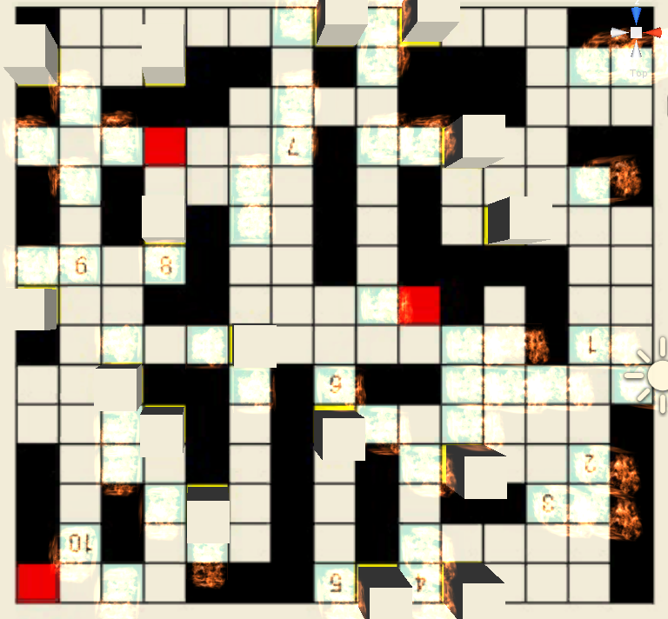

Figure 3 First draft of moving blocks puzzle

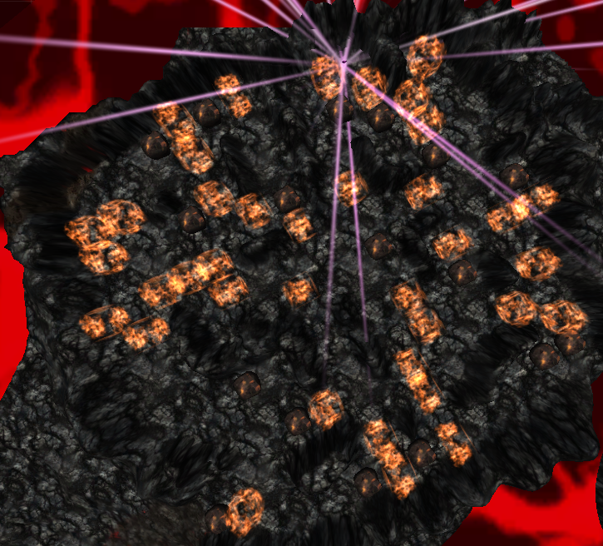

Figure 4 Last version of moving blocks puzzle

### 

### 

### 

### Maze

The player will have to find its way through a maze.

It will feature camera management.

The maze was considered as a bad idea and we changed it to something funnier. A jumping platform mini-game took the place of the maze. It stills feature some of the camera management because the game is far more easy if you move your camera up so you see the top of the head of the character and not his back. If the player goes under the 2 firsts platforms he will experience the zoom system. But this part of the camera behaviour has been moved into the puzzle game because of its narrow space.

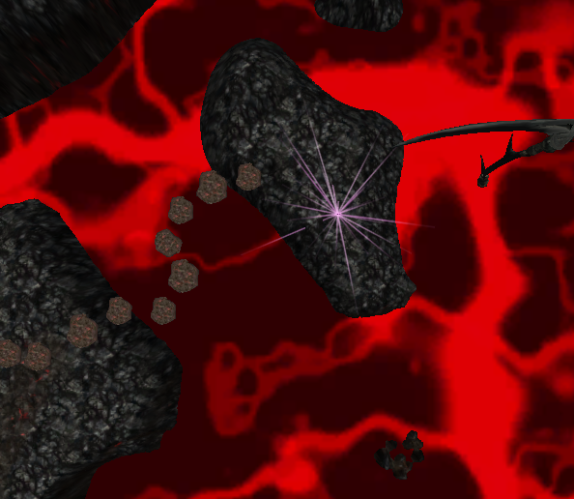

Figure 5 Platform mini-game

### Avoid rocks

The player will have to avoid falling rocks, while stepping carefully on a sliding path, to avoid falling off the cliff.

This part features sliding and gravity physics.

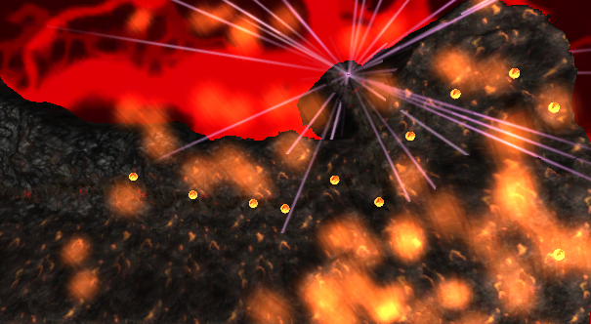

Figure 6 Avoid rocks game

# Ideal game experience

## Introduction

The player may launch the game, in a dark room, alone.

He sees the menu, and three choices are offered to him: play, check the controls or quit. he can select what he wants with the mouse, by a simple click.

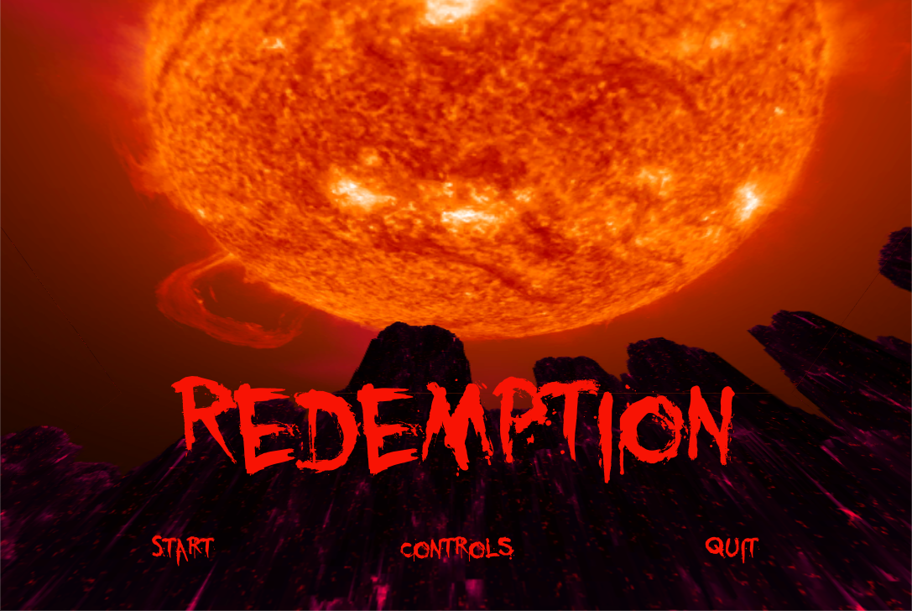

Figure 7 Title screen

Once he’s in the game, he will be introduced the story by a short text, introducing the idea of a gate, and hearts to bring to it.

Being aware of his goal, the player might search for these things:

- The door: it will be visible without moving when the player spawns.

- Hearts: Even though he can’t see them, he’ll see a huge pink particle beam eye-catcher. he might want to go there to check what is in its center.

**Tutorial**

The player will begin on a small land aside of the main terrain. On it stands a first heart, showing the player what exactly he should be seeking during the game. The player will also need to jump to the terrain because there is not much to do on this small rock. When he does so, he will lands just aside of the gate of trials and, if he got the heart just before, the heart will react with the door by disappearing from the hands of the character to appear again near the door. This way, we want the player to understand that he needs to bring the hearts he finds back to the gate.

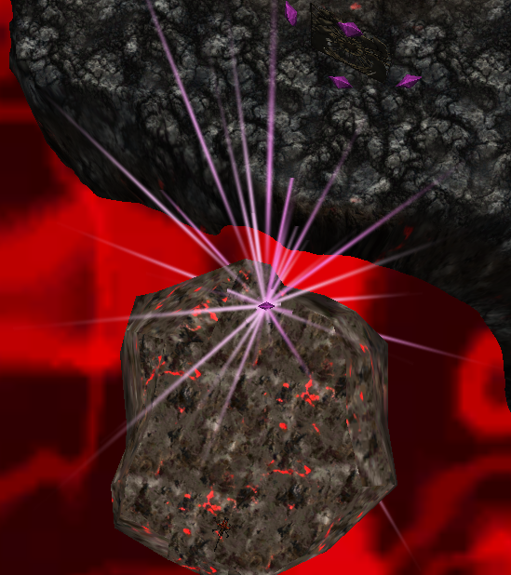

Figure 8 Tutorial

## First trial

If the player goes straight, he’ll get to his first way to get his first heart. This is a platform jumping level, the first two platforms will be permanent to help him train his jumps, and then several others will be blinking to make him speed up and fear his death. There are two ways of succeeding:

- The simple and slow one: don’t miss any platform

- The hard one : skip one platform each time you jump. Not every player will notice this part, but the players who will notice it might feel like they beat the game in a different way, and be able to end the game faster, so they might enjoy it more.

The player should not have any problem to cross the river, because he has plenty of time to see the full path from the beginning with all the platforms. The blinking time is long enough to let the most inexperienced players to get used to the controls and to learn the jumping physics.

Then the player arrives to an island where the first heart lays down. Once he picks it by stepping on it, the particles will disappear and if he stays too long on his island, and big scythe will faint to hit him, this should entice the player to flee the damned island. He’ll be able to walk through a new bridge to help him do so. While on the bridge, particles might attract the player eyes to make him look left, and notice a big eruption, as well as a similar particle as the previous one for the heart. He might get to the door first to put his first heart, then go wander into the place he noticed earlier.

## Second trial

The second trial is a slippery mountain full of falling and burning rocks you have to climb to retrieve the heart to its final destination. The rocks are fired from the top of the mountain and rolling down, some are bouncing down to give an impression of epic and danger. The pattern for each type of rock is not random, so the player can progress and improve after he fails. Some safe spots exist, but 2 safe spots from rolling balls are disturbed sometimes by a bouncing ball.

The first part of the mountain is actually doable without jumping, if the player takes his time to think and learn the pattern. Then after an easy part to let the player think and enjoy the first hard part, a narrow turn is the peak of the trial, where he’ll definitely have to jump over a fireball.

He won’t be able to progress past a point, because he’ll be blocked by an invisible wall and will surely be discouraged by some fire particles fired from the upper part of the mountain, and encourage to pick the heart to the left. One he pick up this heart, the particles signaling its position will stop and a path finding particle will show him the way to get back to the door. He may want to follow it. Once he eventually reach the door and place his newly acquired heart, he might notice the yet again same particles to notify the presence of a heart, so he might understand that it’s where he has to head to.

## 

## Third trial

When picking up the heart from the second trial, the player might see a particle effect being triggered far away in front of him, just above the location of the third and last heart. From where he stands, it could looks like snow falling from the sky, which should surprise him as he currently is in a hell-like environment. After going past the location of the Gate of Trials he should decide to go see what was there, at least to go get the last heart. After climbing a short but slightly slipping slope, the player will find himself stuck by a boulder on his way, easily taking two thirds of the entrance to the trial. Just behind the boulder stands a strange pillar of fire. While trying to make his way up to the slipping slope (maybe while jumping) the player have chances to enter in collision with the boulder which will get pushed inside the fire pillar and will literally get sucked in. The fire pillar and the boulder will then be falling under the ground, letting the player more the space to enter in the last trials and explaining him at the same time how to get rid of the fire pillars.

The third puzzle is a maze-like puzzle where the player is quickly blocked in his way by numerous of those fire pillars. He will have to push the different boulders inside the pillars to make them disappear and make his way through to the location of the heart on the other way. During the trial, the player will certainly notice that the “snow” he might have seen from afar truly is white and translucent human falling from the sky, like ghosts falling from the Hearth to Hell.

There is more than one solution to resolve the maze, and it was thought to make it difficult to get stuck inside, even if there is some dead-ends.

As the fire pillars will randomly be firing fireballs to the player, he will get pressured when going through the maze, even if he can easily avoid those by jumping above or by hiding behind the boulders. In case the player get shot by a fireball his character will be teleported back at the entrance of the puzzle, and the puzzle itself will be reset.

When picking up the heart, all boulders and fire pillars will disappear, letting the player go back safely to the gate of trials.

In every game, the player needs to have a clear goal.

In our game, the goal is to get spirit gems, then to get them back to the door. He can only carry one gem at a time.

He will be on a cliff, and notice 3 ways, and a closed door behind him. He will also see the 3 spirit gems far away, 1 for each way, surrounded by particles so he will want to get it, as he will also see that some obstacles are blocking his path.

Once he gets close to the spirit gem, he will automatically grasp it. As the player might be unsure about what happens now, some particle effect will show him that he needs to get back to the door to get rid of its gem, and start seeking the other ones. As the ways are one-way, it will be a straightforward experience.

# 

# Milestones

- 22 April: Gameplay ideas, draft documentation, workload attribution

- 23 April: Draft of the whole gameplay, draft of the ambiance, brainstorming

- 24 April: 3 puzzles roughly developed separately, first draft of documentation

- 25 April: First draft of the terrain, 3 games design on paper, first draft of the story

- 26 April: Creation of the 3 games

- 27 April: Improvement of the 3 games

- 28 April: End of features development, 3 levels put together, begin playtest

- 29 April: Raw texturing, particles effects, animations, skybox

- 30 April: Enhancements depending on feedback, background story finished, playtest questionnaire

- 1 May: Good looking textures, improvement of the documentation, Bugfixes terrain

- 2 May: Research of good looking 3D models, playtest session with different type of people, Gui

- 3 May: Finishing all about ambiance (texturing, sounds, etc…)

- 4 May: Documentation finished, Game finished

- 5 May: Playtesting and advertising, minor enhancement depending on feedback, bugfixes if needed.

# Story

Arzial, newly born demon realizes after one week of destruction that her path is wrong. She disobeys Lucifer’s orders to kill all the people of a small village, the one where all her family still humans, lived. While seeking redemption, she crosses the path of an angel, Sinius, who tells her the way to become a better being: the Gate of Trials. Sinius brings her to the Gate, but Arzial will have to do the rest and bring 4 pure hearts to it in order to open it and redeem herself.

# Environment

The game follows the story of a demon becoming an angel by succeeding different challenges. We would like the levels to represent the state of goodness of our hero. The first level should be demonic, with fire, lava and dark colors. Then the following level would have a more angelic look, white with light and clouds. Each level should be built around the “Gate of Trials”, and in each level the player would have to bring back spirit(s) diamond(s) to it to go to the next level.

So the firsts levels will look like Hell, or some kind of volcanoes with fire smoke and death relative environment. Then the levels would be an environment more friendly but with elements reminding the player of the previous demonic the the lasts levels would be Heaven with pure white and everything nice.

## Spirit diamond

The first idea was something that would resemble to a half Ying-Yang to show the good part of the hero.

Figure 9 First spirit gem design

Later changed to a heart, because every hero has a pure heart and it represents the change of her heart.

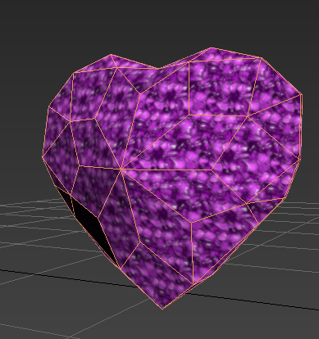

Figure 10 Final spirit gem design

## Hero

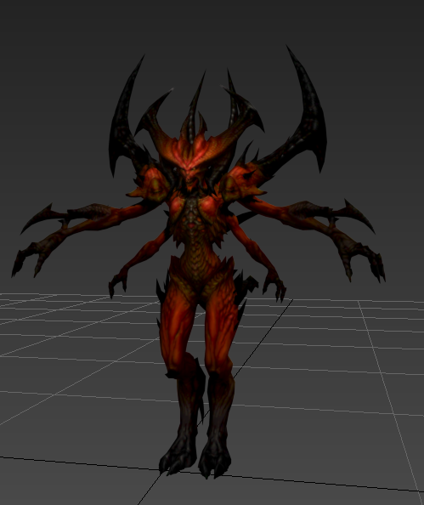

Figure 11 Character model

Our heroine is Diablo from Diablo3 model. We wanted a more human hero but still with a demonic appearance but we couldn’t find a good 3d model of this. And the few we got weren’t imported correctly (texturing problems). So we ended looking for any kind of demon.

## The Gate of Trial

We wanted a gate like a fence so it looks like a gate of Heaven. We didn’t want a gate into a wall but one standing there to add some magic. Like the good part of yourself isn’t locked behind a wall or anything but it’s just a state of mind and the only thing preventing you to become a good person is yourself. So the door represents the imaginary lock that prevents the demon to become good, because the demon is already good for searching redemption.

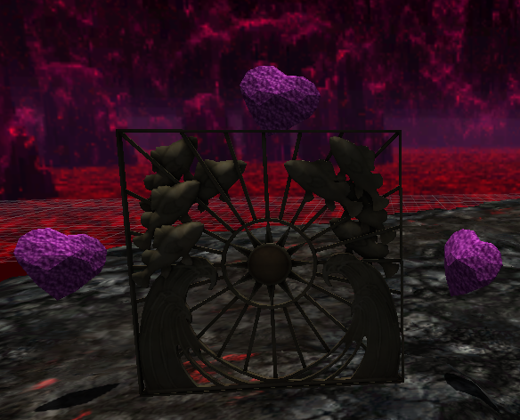

Figure 12 Gate of Trials

## Music

We used three tracks for the game:

* One for the main menu “Battle in the land of the Dead” from music studio Basiscape, initially composed for the game Odin Sphere.
* One as main background music during the game “Battle in the land of fire”, also from Odin Sphere.
* One for the victory screen once the game is over “The hero’s triumphant return”, also from Odin Sphere.

# ANNEXES:

**3D Game Design – Game testing questionnaire**

**Disclaimer:**

Any collected data will only be used strictly within the making of the final game. Any published findings (e.g. in reports or academic papers) from the development will be anonymised: participants’ confidentiality will be preserved.

By signing below, I consent to participate in the research study, as described above:

Signed:

Participant ID: __________

Name:____________ __________

Date: _______________

**Are you Male or Female? (Please Tick One)**

Male ¨

Female ¨ **Age:** _______

**How much time do you spend playing video games each week?**

I don’t play video games at all ¨

Less than 1 hour per week ¨

I play 1 to 4 hours a week ¨

I play 4 to 7 hours a week ¨

I play 7 to 14 hours a week ¨

I play more than 14 hours a week ¨

**What kind of game do you play?**

_____________________________

**Please rate the level of difficulty of the game:**

Perfect

Too easy! |---------------------------------------|---------------------------------------| Too hard…

**Did you finish the game?**

Yes ¨

No¨

**If “No”, why?**

**______________________________________________________________________________________________________________________________________________________________________________________________________________________________________________________________________**

**Please rate the fun you had playing of the game:**

Neutral K

Boring L |---------------------------------------|---------------------------------------| Funny J

**Did you enjoy the game?**

Yes ¨

No ¨

**Explain**:

____________________________________________________________________________________________________________________________________________________________________________________________________________________________________________________________________________________

**Would you play the game again?**

Yes ¨

No ¨

**What part of the game did you like/dislike?**

Jumping platform ¨

Rock avoiding ¨

Puzzle ¨

**Comments:**

_________________________________________________________________________________________________________________________________________________________________________________________________________

**Do you have any suggestions to improve the game?**

_________________________________________________________________________________________________________________________________________________________________________________________________________

Thanks for your time! ☺

**3D Game Design – Experimental Playtest Script**

**Experiment Preparation:**

- One laptop with the game open

- Documents laid out

- Pens laid out

**Welcome the Tester participants**

Dialogue: “Hello, please take a seat”

*Action: Show the volunteer where to sit*

Dialogue: “Thank you for volunteering to take part in this playtest”

**Introduce yourself**

Dialogue: “Hello my name is Matthieu Bourgeon; here are Florian Fremeaux and Thierry Berger. We are master students in game programming”

**Explain the project and experiment to the participant**

Dialogue: “This game is my midterm exam. To test it, we will be observing your behaviour while you play. Before and after playing the game we will be asking you to participate in a questionnaire of the game, which we will be using to improve the game”

**Ask the participant to play**

Dialogue: “You can start playing the game now”

*Action: Wait until the participant finish the game or give up (maximum of 20min)*

**Event – The player starts to get frustrated about the controls and/or get to the last part of the game**

Dialogue**: “**WASD is for moving the character; you have to use the mouse to look around. If you want to move rocks: press the left mouse button when you are in front of the rock.”

**Observe and note any interesting behaviour**

*Action: Take out notepad and observe behaviour*

- Frustration

- Confusion

- Enjoyment

**Ask the participant to complete the post-playtest questionnaire**

Dialogue: “We need you to complete this questionnaire”

*Action: Hand to volunteer the questionnaire*

Dialogue: “Please take your time and let me know when you are finished”

**On completion of the questionnaire**

Dialogue: “Thank you for completing the questionnaire”

*Action: Take the questionnaire and file it*

**Thank the participant for taking part in the playtest**

Dialogue: “This concludes the playtest, thank you for taking the time to volunteer for it. Have a nice day.”

*Action:* *Wave hand and smile*